CREATE DATABASE Ecommerce_DB;

USE Ecommerce_DB;

| customer_id | customer_name |
| ----------- | ------------- |
| 101 | Ravi |
| 102 | Priya |
| 103 | Kumar |
| 104 | Anitha |

CREATE TABLE Customers (
customer_id INT PRIMARY KEY,
customer_name VARCHAR(100)
);

| order_id | customer_id | product_id |
| -------- | ----------- | ---------- |
| 1001 | 101 | 501 |
| 1002 | 102 | 502 |
| 1003 | 105 | 503 |

CREATE TABLE Orders (
order_id INT PRIMARY KEY,
customer_id INT,
product_id INT
);

| product_id | product_name | category_id |
| ---------- | ------------ | ----------- |
| 501 | Laptop | 1 |
| 502 | Mouse | 2 |
| 503 | Keyboard | 2 |

CREATE TABLE Products (
product_id INT PRIMARY KEY,
product_name VARCHAR(100),
category_id INT
);

| category_id | category_name |
| 1 | Electronics |
| 2 | Accessories |

CREATE TABLE Categories (
category_id INT PRIMARY KEY,
category_name VARCHAR(100)
);

INSERT INTO Customers VALUES
(101,'Ravi'),
(102,'Priya'),
(103,'Kumar'),
(104,'Anitha');

SELECT * FROM Customers;

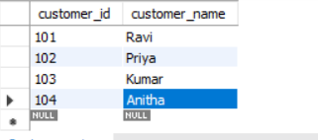

INSERT INTO Orders VALUES
(1001,101,501),
(1002,102,502),
(1003,105,503);

SELECT * FROM Orders;
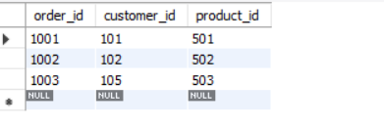

INSERT INTO Products VALUES
(501,'Laptop',1),
(502,'Mouse',2),
(503,'Keyboard',2);

SELECT * FROM Products;

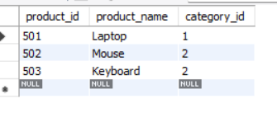

INSERT INTO Categories VALUES
(1,'Electronics'),
(2,'Accessories');
SELECT * FROM Categories;
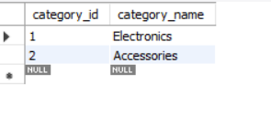
INNER JOIN
customer_id | customer_name
101 | Ravi
102 | Priya
103 | Kumar
104 | Anitha

order_id | customer_id | product_id
1001 | 101 | 501
1002 | 102 | 502
1003 | 105 | 503

product_id | product_name | category_id
501 | Laptop | 1
502 | Mouse | 2
503 | Keyboard | 2

category_id | category_name
1 | Electronics
2 | Accessories

SYNTAX

SELECT
C.customer_name,
O.order_id,
P.product_name,
CA.category_name
FROM Customers C
INNER JOIN Orders O
ON C.customer_id = O.customer_id
INNER JOIN Products P
ON O.product_id = P.product_id
INNER JOIN Categories CA
ON P.category_id = CA.category_id;

OUTPUT
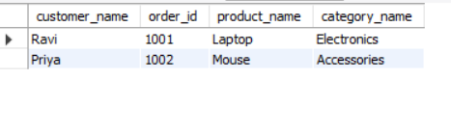

LEFT JOIN

customer_id | customer_name
101 | Ravi
102 | Priya
103 | Kumar
104 | Anitha

order_id | customer_id | product_id
1001 | 101 | 501
1002 | 102 | 502
1003 | 105 | 503

product_id | product_name | category_id
501 | Laptop | 1
502 | Mouse | 2
503 | Keyboard | 2

category_id | category_name
1 | Electronics
2 | Accessories

SYNTAX

SELECT
C.customer_name,
O.order_id,
P.product_name,
CA.category_name
FROM Customers C
LEFT JOIN Orders O
ON C.customer_id = O.customer_id
LEFT JOIN Products P
ON O.product_id = P.product_id
LEFT JOIN Categories CA
ON P.category_id = CA.category_id;

OUTPUT
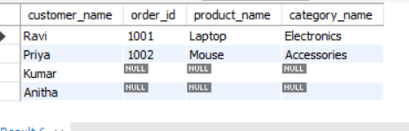

RIGHT JOIN

customer_id | customer_name
101 | Ravi
102 | Priya
103 | Kumar
104 | Anitha

order_id | customer_id | product_id
1001 | 101 | 501
1002 | 102 | 502
1003 | 105 | 503

product_id | product_name | category_id
501 | Laptop | 1
502 | Mouse | 2
503 | Keyboard | 2

category_id | category_name
1 | Electronics
2 | Accessories

SYNTAX

SELECT
C.customer_name,
O.order_id,
P.product_name,
CA.category_name
FROM Customers C
right JOIN Orders O
ON C.customer_id = O.customer_id
right JOIN Products P
ON O.product_id = P.product_id
right JOIN Categories CA
ON P.category_id = CA.category_id;

OUTPUT

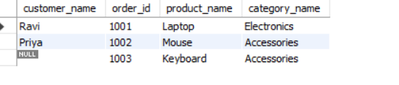

UNION JOIN

customer_id | customer_name
101 | Ravi
102 | Priya
103 | Kumar
104 | Anitha

order_id | customer_id | product_id
1001 | 101 | 501
1002 | 102 | 502
1003 | 105 | 503

product_id | product_name | category_id
501 | Laptop | 1
502 | Mouse | 2
503 | Keyboard | 2

category_id | category_name
1 | Electronics
2 | Accessories

SYNTAX

SELECT
C.customer_name,
O.order_id,
P.product_name,
CA.category_name
FROM Customers C
LEFT JOIN Orders O
ON C.customer_id = O.customer_id
LEFT JOIN Products P
ON O.product_id = P.product_id
LEFT JOIN Categories CA
ON P.category_id = CA.category_id

union

SELECT
C.customer_name,
O.order_id,
P.product_name,
CA.category_name
FROM Customers C
right JOIN Orders O
ON C.customer_id = O.customer_id
right JOIN Products P
ON O.product_id = P.product_id
right JOIN Categories CA
ON P.category_id = CA.category_id;

OUTPUT

